**Catch the Donut**

1. Delete the Sprite 1 (the cat) and add a new sprite from the library (Donut).
2. Create a variable Score and make it visible on the stage.
3. Create the following Backdrop (as a bitmap).

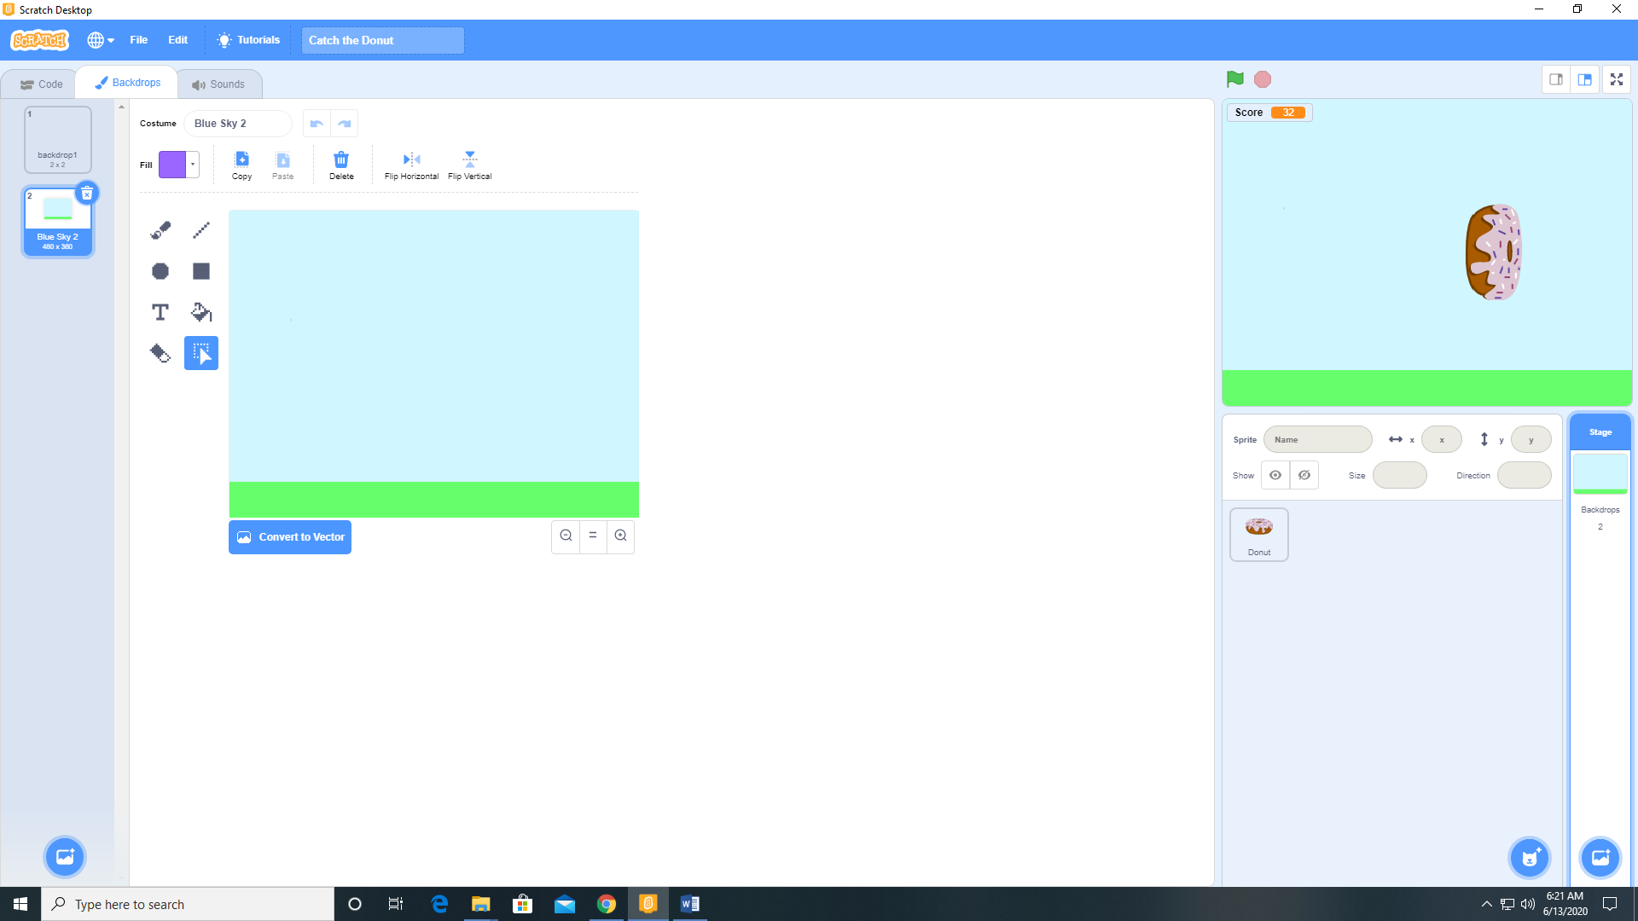

1. Add the following code to the Donut sprite.

